I Stored Engagement Metrics in Hindsight and Rewrote My Schema
Every content tool I've used forgets by Thursday. It forgets which angle flopped last quarter, which topics we've already beaten to death, and the fact that we quietly stopped writing like a press release in March. So I built a content strategy agent whose memory is the product, and I put that memory behind a single module so I could swap out how it works without touching anything else.

What the system does and how it hangs together
It looks like something like this
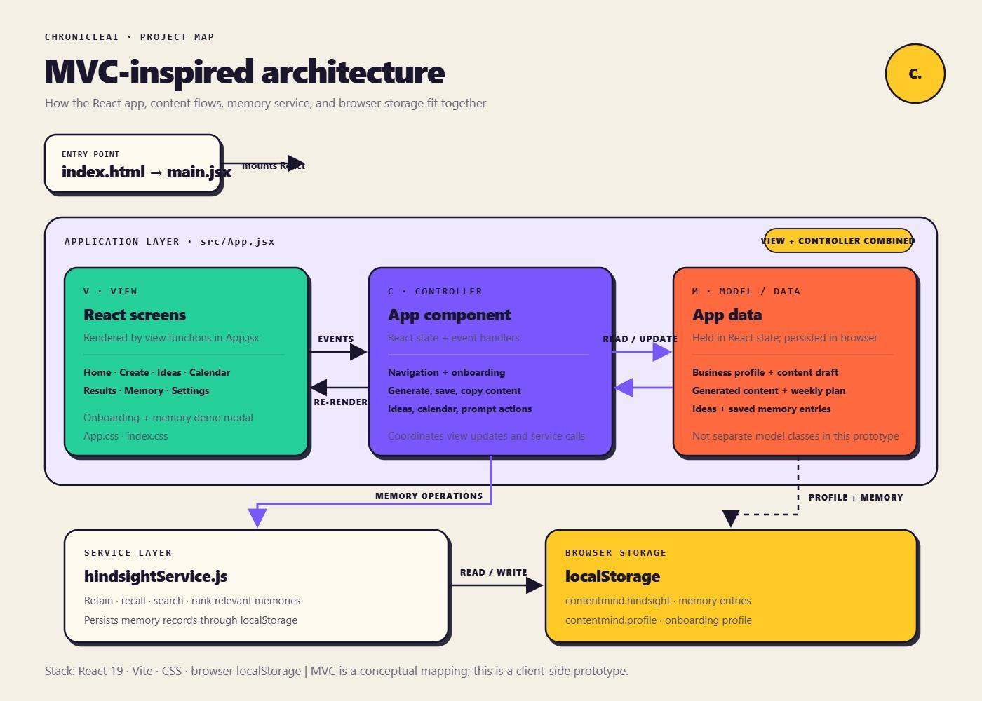
The app helps a small marketing team decide what to write next and then helps them write it. The screens map to the workflow: Home, Create, Ideas, Calendar, Results, Memory, and Settings. Onboarding captures a business profile (who we are, who we write for, how we sound). From there the app generates content, saves drafts, builds a weekly plan, keeps a list of ideas, and records how published pieces performed.
Structurally it's a React 19 + Vite client with plain CSS. I describe it as MVC-inspired, and I want to be honest about what that means. It's a conceptual mapping, not a framework:
- View: the screen-rendering functions in App.jsx.
- Controller: the App component itself, meaning React state and event handlers. It handles navigation, onboarding, generating, saving, copying, and prompt actions.
- Model: the app data held in React state. That's the business profile, the current draft, generated content, the weekly plan, ideas, and saved memory entries. There are no model classes, and I've stopped pretending there should be.
The one piece that isn't in that trio is the service layer. hindsightService.js is the only file in the codebase that knows how memory works. The controller asks it to retain, recall, search, and rank. It never asks how.
That seam is the whole story of this article.

The through-line: memory behind one door
My first version of memory was the obvious one: an array of entries in localStorage, plus a keyword match to pull "relevant" ones into a prompt. It shipped in a day and it worked well enough to show me what I actually needed.
I'm not going to dress up what was wrong with it. Keyword matching found entries that mentioned a topic. It couldn't tell me that an entry from January contradicted one from May. Two notes, "technical readers prefer short code snippets" and "our best-performing pieces this quarter were architecture deep dives," would both come back for the same query, and the model would try to average them into something incoherent.
This is the failure that plain vector search has too, and I think it's underrated. Similarity search retrieves text that looks like the query. It has no opinion on which of two similar-looking facts is current. For a content strategy tool, where the entire value is knowing what changed, that's disqualifying.
I moved the real implementation onto Hindsight, an open-source agent memory system. What I wanted from it was specific:
- It structures what you retain into entities, facts, and time relationships instead of storing raw text.
- Retrieval runs several strategies in parallel (semantic, keyword, graph, and temporal) rather than betting on one.
- Retrieval takes a budget, so I control how much memory lands in the prompt.
- Memory lives in named banks, which gives me a natural isolation boundary per workspace.
If you want the background on why that's a different thing from "a vector database with extra steps," Vectorize's explainer on what agent memory actually is is a good primer. I'd read it before evaluating any memory layer, mine or anyone else's.
Because everything went through hindsightService.js, the migration was mostly a rewrite of one file. The controller's call sites barely changed. That is the design decision I'd defend hardest.

The service contract
The module exposes four operations. The signatures are the contract; the implementation behind them is what changed.
js
// hindsightService.js
import { HindsightClient } from '@vectorize-io/hindsight-client';

// The browser never talks to Hindsight directly. It talks to our own
// thin proxy, which holds credentials and resolves the bank from the session.
const client = new HindsightClient({ baseUrl: '/api/memory' });

export async function retain(bankId, { content, context, occurredAt }) {
return client.retain(bankId, content, {
context,
timestamp: occurredAt ?? new Date().toISOString(),
});
}

export async function recall(bankId, query, { budget = 'mid' } = {}) {
return client.recall(bankId, query, { budget });
}

export async function search(bankId, query) {
return client.recall(bankId, query, { budget: 'low' });
}
Two details here matter more than they look.
First, timestamp. The original localStorage entries had a createdAt that meant "when the user clicked save." Hindsight wants to know when the thing happened, because its temporal retrieval depends on it. A retrospective saved today about last quarter's campaign should be dated to last quarter. I had to go back through the Results screen and make it ask for a publish date instead of defaulting to now. That was tedious, and it was the single change that most improved recall quality.
Second, the proxy. In the prototype, localStorage was fine because it was local. A memory service with real credentials is not something you call from a browser bundle. So the client points at our own endpoint, which authenticates the session and maps it to a bank. The service module doesn't know or care; it just gets a bankId.

Recall before generating
Here's the controller side of the Create screen. When someone asks for a draft, the handler recalls first and generates second:
js
// App.jsx (controller)
async function handleGenerate(brief) {
setStatus('recalling');

const memories = await recall(
workspaceId,
`What has worked and what hasn't for: ${brief.topic}? ` +
`What have we already published on this?`,
{ budget: 'high' }
);

setStatus('generating');
const draft = await generateContent({
profile: businessProfile,
brief,
memory: memories.results.map((m) => m.text),
});

setContentDraft(draft);
setStatus('idle');
}
I phrase the recall as a question with two parts on purpose. "What worked" pulls performance history. "What have we already published" pulls coverage. The model gets both in one pass, which is what lets it say "you covered this in the spring, here's an angle you haven't used" instead of cheerfully writing the same post again.
Recall runs before generation every time. I considered making it a tool the model could choose to call, and I might still, but for this workflow "always look before you write" is the right default. A model that decides whether to consult its own memory will sometimes decide wrong, and the failure is silent.

Retaining what actually happened
Recall is only as good as what goes in. The other half is the Results screen, where a person records how a published piece did:
js
// App.jsx (controller)
async function handleSaveResult(piece, outcome) {
await retain(workspaceId, {
content:
`"${piece.title}" (${piece.format}, topic: ${piece.topic}) ` +
`${outcome.summary}`,
context: `Performance review for ${piece.channel}`,
occurredAt: piece.publishedAt,
});

setMemoryEntries((prev) => [...prev, toMemoryEntry(piece, outcome)]);
}
I write the content as a plain sentence with the piece's title, format, and topic in it, not as a JSON blob. Hindsight extracts entities and facts from natural language, so a sentence that names the format and the topic gives it something to build relationships from. My first attempt stuffed structured fields into the content string and the extraction was noticeably worse. Write to it the way you'd write to a colleague.
The local memoryEntries state still exists. It powers the Memory screen so people can see and audit what the system knows. I didn't want memory to be a black box, and I'd advise the same for anyone building this: if users can't inspect what the agent remembers, they won't trust what it says.
The Hindsight documentation covers banks, retain options, and recall budgets in more detail than I can here, and I found it more useful than trial and error.

Behavior in practice
Here's the kind of interaction this produces. Suppose the team has retained several performance notes over a few months: a run of listicles that were recorded as underperforming, and a set of architecture-focused deep dives recorded as doing well. A user opens Create and types:
Draft an outline for our upcoming release announcement.
Before generating anything, the controller recalls against that topic. What comes back is the deep-dive history and the earlier listicle notes, with the time ordering intact. The generated outline leans toward architecture and explains why, referencing the earlier pieces instead of guessing.
A second example is the question the Ideas screen exists to answer:
What did we cover during the infrastructure push, and what's still missing?
That's a coverage question, and it's the case where keyword matching failed me hardest. Because recall is anchored to entities and time, "the infrastructure push" resolves to a period and a set of topics, and the gaps are whatever the plan hasn't touched.
I'm deliberately not putting numbers on any of this. I haven't run a controlled comparison, and I don't trust writeups that quote engagement lifts from a single team's month. What I can say is that the drafts stopped repeating themselves, and the Memory screen makes it easy to check why a draft took the angle it did.

Lessons learned
1. Put memory behind a boundary before you know which memory you want. I would not have gotten the retrieval design right on my first try. Because every memory operation went through one module, I could start with localStorage, learn what was wrong, and replace it without rewriting the app. The abstraction paid for itself the first time I used it.
2. Retrieval that can't handle contradiction is a bug, not a limitation. If your domain involves things that change (preferences, strategy, performance), similarity alone will eventually hand your model two opposing facts. Pick a memory layer that treats time as a first-class concept.
3. Timestamp the event, not the save. This one hurt. Storing "when the user clicked the button" instead of "when it happened" silently poisons temporal retrieval. Audit your write paths for it.
4. Recall by default in workflows where forgetting is the failure. Letting the model decide whether to consult memory is elegant right up until it doesn't. For a writing tool, make the lookup unconditional and spend your cleverness on the query.
5. Show users the memory. A Memory screen costs a day of work and buys a lot of trust. When the agent makes a strange call, the fastest debugging tool is being able to see what it thought it knew.
The React app itself is unremarkable, and I mean that as a compliment. The interesting decisions live in the seam between the controller and hindsightService.js, and getting that one boundary right made everything after it cheaper.

